This project goal is to grasp the complexity of how MVC works while using ms sql. This is a simple projection of how and its basic knowledge for it to work. And now to start with...



Let's understand the MVC architecture supported in ASP.NET.

MVC stands for Model, View, and Controller. MVC separates an application into three components - Model, View, and Controller.

**Model**: Model represents the data. A class in C# is used to describe a model. Model objects store data retrieved from the database.

**View**: View in MVC is a user interface. View display model data to the user and also enables them to modify them. *View* in ASP.NET MVC is HTML, CSS, and some special syntax (Razor syntax) that makes it easy to communicate with the model and the controller.

**Controller**: The controller handles the user request. Typically, the user uses the view and raises an HTTP request, which will be handled by the controller. The controller processes the request and returns the appropriate view as a response.

This is how MVC is doing its work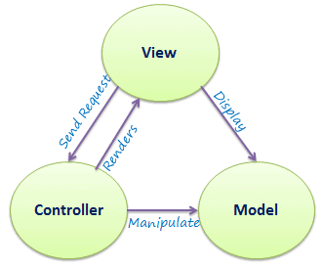

The following figure illustrates the interaction between Model, View, and Controller.

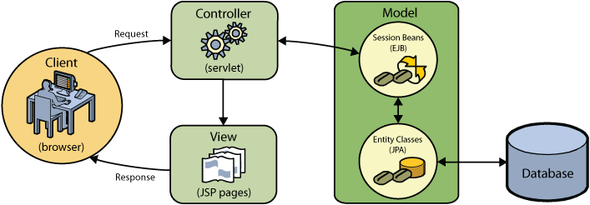

**MS SQL Database**

MSSQL is a suite of database software published by Microsoft and used extensively within our enterprise. Typically, it includes a relational database engine, which stores data in tables, columns and rows, Integration Services (SSIS), which is a data movement tool for importing, exporting and transforming data, Reporting Services (SSRS), which is used to create reports and serve reports to end users, and also Analysis Services (SSAS), which is a multidimensional database used to query data from the main database engine.

Below is an example of this simple projects code using MVC and MS SQL. This is what the model looks like, when accessing it is somewhat just like an array.

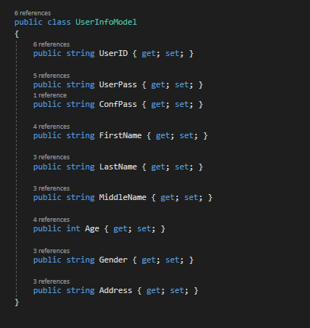

And this is what the controller would look like for accessing login

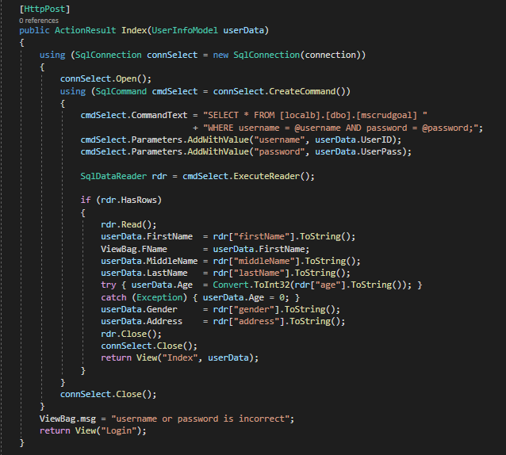

And for MS SQL connection string

